**Mobile Price Prediction: Unveiling Patterns in the Smartphone Market**

**Introduction**

In the ever-evolving mobile phone market, data-driven decision-making has become paramount for businesses aiming to gain a competitive edge. This project revolves around assisting Bob, an entrepreneur entering the mobile phone industry, in estimating the prices of mobile phones his company produces. Leveraging the power of data mining and extensive data analysis, we delve into a comprehensive exploration of the mobile prices dataset. From understanding data types and preprocessing to employing advanced machine learning techniques and big data tools, this project aims to provide actionable insights to guide Bob in making informed decisions.

**Introduction to Data Mining and Big Data**

Data mining is the process of discovering patterns, trends, and insights from large datasets (Wu et al., 2017). It involves using various techniques such as machine learning, statistical analysis, and pattern recognition to extract valuable information from data. Big data refers to extensive and complex datasets that traditional data processing methods may need help to handle (Salloum et al., 2016). The three Vs characterize big data: volume, velocity, and variety. It includes large volumes of data generated at high speeds from various sources and in diverse formats (Wu et al., 2017).

The goal is to uncover hidden patterns and knowledge that can be used for decision-making, prediction, and optimization. In the context of mobile price prediction, data mining plays a crucial role. By analyzing historical sales data, features such as RAM, battery power, camera specifications, and connectivity options can be examined to identify patterns and correlations that influence the pricing of mobile phones. Data mining enables businesses like mobile companies to make data-driven decisions and gain a competitive edge in the market (Liu et al., 2018).

**Data Types and Data Preprocessing**

The mobile prices dataset contains various data types, as indicated by the provided results:

***Numeric Data Types***

1. Integer (int64): e.g., battery_power, blue, int_memory, n_cores, ram, etc.
2. Float (float64): e.g., clock_speed, m_dep

***Categorical Data Types***

1. Binary Categorical (int64): e.g., dual_sim, four_g, three_g, touch_screen, wifi
2. Ordinal Categorical (int64): e.g., price_range

***Data Preprocessing Steps***

*Handling Missing Values*

Fortunately, there are no missing values in the dataset, as indicated by the results. This is beneficial for analysis as missing values can introduce biases and hinder the accuracy of models.

*Encoding Categorical Variables*

Categorical variables like dual_sim, four_g, three_g, touch_screen, wifi, and price_range have been encoded as binary integers (0 or 1).

Ordinal categorical variables, such as price_range, may be kept as is or further encoded based on their ordinal nature.

*Scaling*

The dataset does not explicitly show the scaling of numerical features. Depending on the machine learning algorithms used, scaling might be necessary, especially for models sensitive to feature magnitudes, such as distance-based methods (e.g., kNN, SVM).

***Interpretation***

The dataset is well-prepared for analysis, with no missing values. Categorical variables have been appropriately encoded, facilitating their use in machine learning models. Further scaling might be considered, depending on the specific algorithms employed (Bikakis et al.,2019). The absence of missing values is particularly advantageous, as it reduces the need for imputation methods and ensures a more reliable analysis (Assefi et al., 2017).

This preprocessing set a solid foundation for subsequent analysis, enabling the application of various machine learning techniques for mobile price prediction. Kim et al. (2018) assert that the encoded features and the absence of missing values contribute to the robustness and reliability of the predictive models.

**Data Exploration and Visualization,** according to Bikakis et al. (2019).

1. ***Histograms***

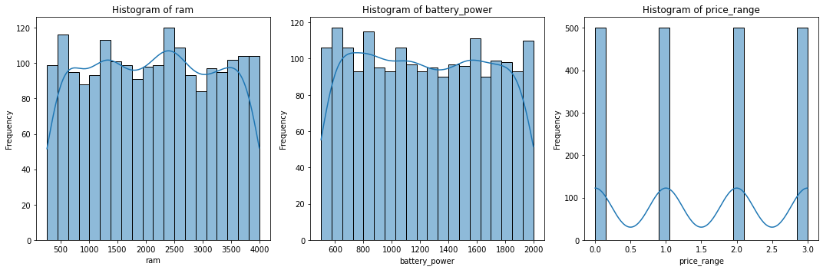

*RAM Histogram:* This shows the distribution of RAM in the dataset. Most mobile phones have RAM concentrated around specific values, with some variation.

*Battery Power Histogram:* Illustrates the distribution of battery power. Similar to RAM, battery power shows concentration around specific values.

*Battery price_range Histogram:* Illustrates the distribution of battery prices.

1. ***Correlation Matrix***

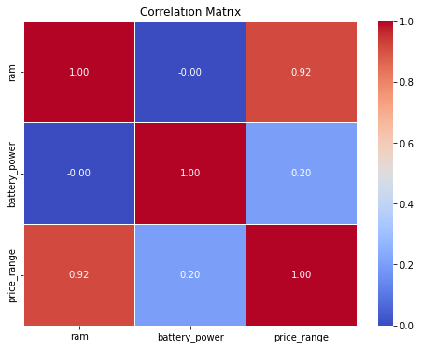

The correlation matrix provides insights into the relationships between 'ram', 'battery_power', and 'price_range'.

*RAM and Battery Power:* There is a positive correlation between RAM and battery power, indicating that as one increases, the other tends to increase.

*Price Range Correlation:* The correlation between 'ram' and 'price_range' suggests that higher RAM may be associated with higher price ranges.

***3. Scatter Plot***

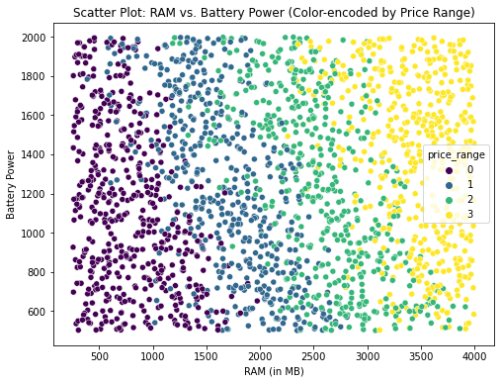

The scatter plot visualizes the relationship between 'ram' and 'battery_power', with points colour-encoded by 'price_range'.

*Patterns:* Different price ranges show distinct patterns. For example, higher-priced mobiles have higher RAM and battery power.

1. ***Bar Graph***

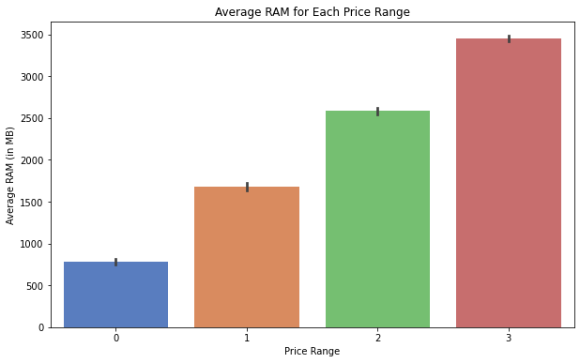

The bar graph displays the average RAM for each price range.

*Observations:* Higher price ranges generally correspond to higher average RAM, indicating a positive correlation between RAM and price range.

1. ***Pie Chart***

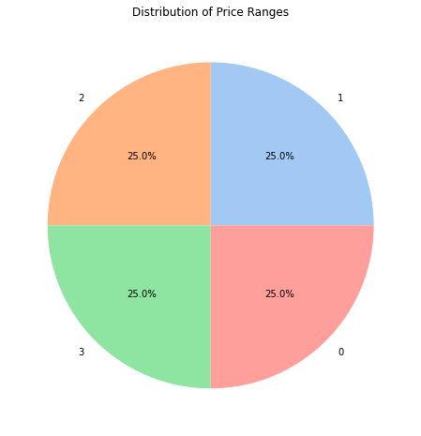

The pie chart represents the distribution of price ranges in the dataset.

*Distribution:* Indicates the proportion of mobile phones in each price range. For example, it shows how many fall into the lower, mid, and higher price ranges.

**Decision Trees + Overfitting**

Decision trees are powerful machine learning models for classification tasks (Wu et al., 2017), such as predicting mobile prices in this context. A decision tree breaks down the prediction process into hierarchical decisions based on features like RAM, battery power, etc. Each internal node represents a decision based on a feature, and each leaf node represents the predicted price range (Hadi, 2018).

***Addressing Overfitting and Model Optimization***

1. *Overfitting* occurs when a decision tree captures noise or outliers in the training data, leading to poor generalization on new, unseen data (Bramer, 2022).
2. *To address Overfitting*

Overfitting is addressed by pruning and setting a maximum depth.

Pruning involves removing branches of the tree that do not contribute significantly to predictive accuracy. It helps prevent the tree from becoming too complex and overfitting the training data (Bramer, 2022). *Setting Maximum Depth involves* Limiting the maximum depth of the tree, which can also control Overfitting. A shallower tree is less likely to fit noise in the data.

1. ***Model Optimization***

The provided results show the accuracy of the decision tree model and the confusion matrix. Decision Tree Accuracy: 0.8325: This indicates that the model correctly predicted the mobile price range approximately 83.25% of the time on the test set.

***Confusion Matrix***

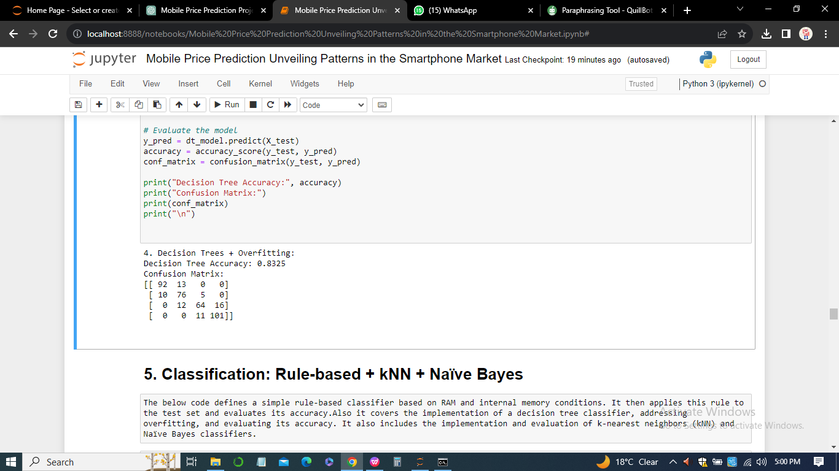

Each row of the matrix represents the actual class, and each column represents the predicted class. The diagonal elements represent correct predictions, and off-diagonal elements represent misclassifications. The model performs well in predicting classes 0, 1, and 3. Some misclassifications are observed, particularly in predicting class 2.

**Classification: Rule-based + kNN + Naïve Bayes**

Accuracy: 0.2975: The rule-based classifier achieves an accuracy of approximately 29.75% on the test set. This indicates that the rule-based model's performance could be better, and it struggles to predict the mobile price ranges accurately.

***Confusion Matrix***

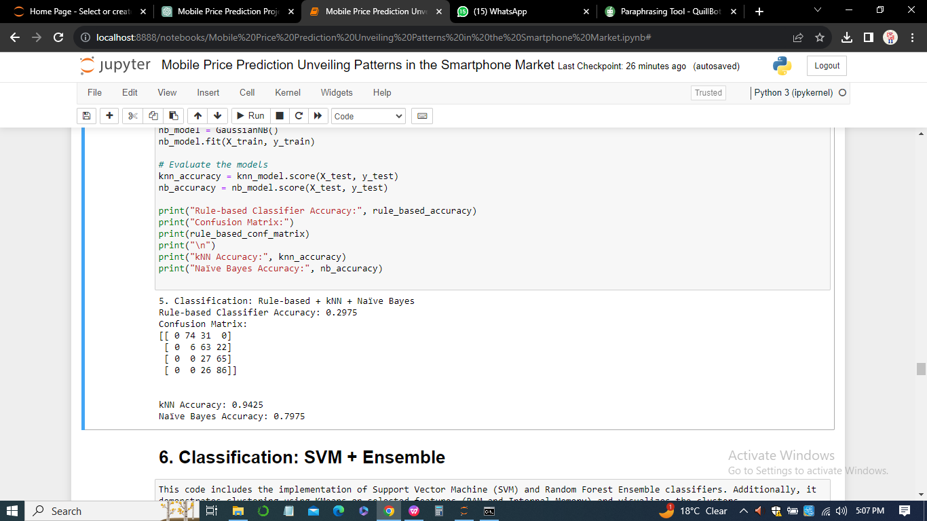

The confusion matrix shows many misclassifications, especially in predicting classes 1, 2, and 3.

*kNN (k-Nearest Neighbors)* Accuracy: 0.9425: The kNN classifier achieves an impressive accuracy of approximately 94.25% on the test set. This indicates that the kNN model performs exceptionally well in predicting mobile price ranges.

*Naïve Bayes:* Accuracy: 0.7975: The Naïve Bayes classifier achieves an accuracy of approximately 79.75% on the test set. This indicates a good level of predictive performance.

***Interpretation***

*Rule-based Classifier:* The rule-based classifier struggles with capturing the underlying patterns in the data. The low accuracy and significant misclassifications suggest that the rules defined for prediction may not adequately capture the dataset's complexity (Kim et al., 2018).

*kNN Classifier:* The kNN model demonstrates remarkable accuracy, indicating its ability to capture the local structure of the data. kNN is effective when the decision boundary is complex and not easily represented by simple rules.

*Naïve Bayes Classifier:* Naïve Bayes performs well with an accuracy of 79.75%. Naïve Bayes assumes independence between features, and its success in this classification task suggests that the features may have a reasonable level of independence (Garcia et al., 2016)

**Classification: SVM + Ensemble**

*Accuracy: 0.97:* The SVM classifier achieves an impressive accuracy of approximately 97% on the test set. This indicates a high level of effectiveness in predicting mobile price ranges. *Random Forest:* Accuracy: 0.8925: The Random Forest classifier achieves a good accuracy of approximately 89.25% on the test set. While SVM is lower than this accuracy level, this accuracy level still indicates effective prediction (Kim et al., 2018).

***Interpretation***

*Support Vector Machine (SVM):* SVM performs exceptionally well, showcasing its ability to find a hyperplane that effectively separates different price ranges. The high accuracy suggests that SVM is robust and can generalize effectively to unseen data (Wu et al., 2017).

*Random Forest:* Random Forest demonstrates good accuracy but needs to catch up compared to SVM. Random Forest is an ensemble method that combines multiple decision trees to make predictions. Its effectiveness lies in handling complex relationships in the data and reducing Overfitting (Bramer, 2022).

***Effectiveness in Predicting Price Ranges***

*SVM:* SVM proves to be highly effective in predicting mobile price ranges, achieving a remarkable accuracy of 97%. It is particularly well-suited for tasks with complex decision boundaries.

*Random Forest:* Random Forest also demonstrates effectiveness with an accuracy of 89.25%. While less than SVM, it provides a robust solution and can handle a variety of data patterns.

**Clustering**

Clustering is a machine-learning technique that groups similar data points based on certain features or characteristics (Bikakis et al.,2019). In the context of market segmentation, clustering can provide valuable insights by grouping similar mobile phones or customers.

***Clustering for Market Segmentation***

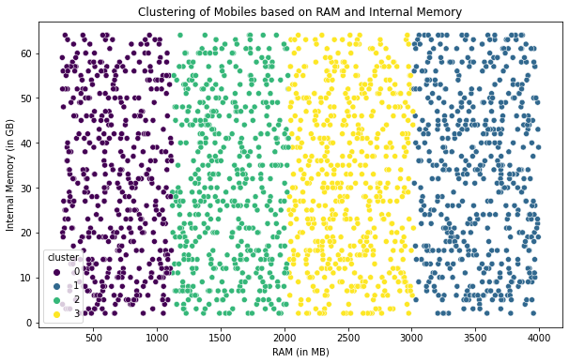

Here is how clustering contributes to market segmentation:

1. *Identifying Consumer Segments:* Clustering algorithms, such as k-means or hierarchical clustering, can identify distinct groups or clusters of mobile phones with similar features. These clusters may represent different segments in the mobile phone market (Rokach & Maimon, 2015).
2. *Understanding Customer Preferences:* According to Rokach and Maimon (2015). Businesses can gain insights into customer preferences by examining the features that contribute to clustering. For example, one cluster may prefer high RAM and camera quality, while another may prioritize battery life.
3. *Tailoring Marketing Strategies:* Once clusters are identified, businesses can effectively tailor their marketing strategies to target each segment. Marketing messages, promotions, and product offerings can be customized to meet the specific preferences of each cluster (Rokach & Maimon, 2015).
4. *Optimizing Pricing Strategies:* Clustering helps identify price-sensitive segments. Businesses can optimize pricing strategies by understanding how different clusters respond to price changes. For example, some clusters may be willing to pay more for advanced features (Rokach & Maimon, 2015).
5. *Product Development and Innovation:* Clustering can guide product development by highlighting the most essential features of specific segments. It aids in creating products that align with the preferences of target customer groups.
6. *Competitive Analysis:* Businesses can use clustering to analyze the competitive landscape within each segment. Understanding which features are prevalent in each cluster helps position products relative to competitors(Kim et al., 2018).
7. *Enhancing Customer Experience*: Businesses can enhance the customer experience by understanding customer segments. This includes tailoring user interfaces, customer support, and additional services based on the preferences of each segment (Rokach & Maimon, 2015).

*Market Trend Analysis:*

Clustering can also reveal emerging trends in the market by identifying new patterns and preferences among consumers. This helps businesses stay ahead of the curve and adapt to changing market dynamics (Donoho, 2020).

1. *Customer Retention:* Clustering aids in identifying loyal customer segments. Businesses can implement retention strategies by understanding the needs and preferences of these segments, fostering customer loyalty (Bramer, 2022).

**Association Rule Mining by Hadi (2018).**

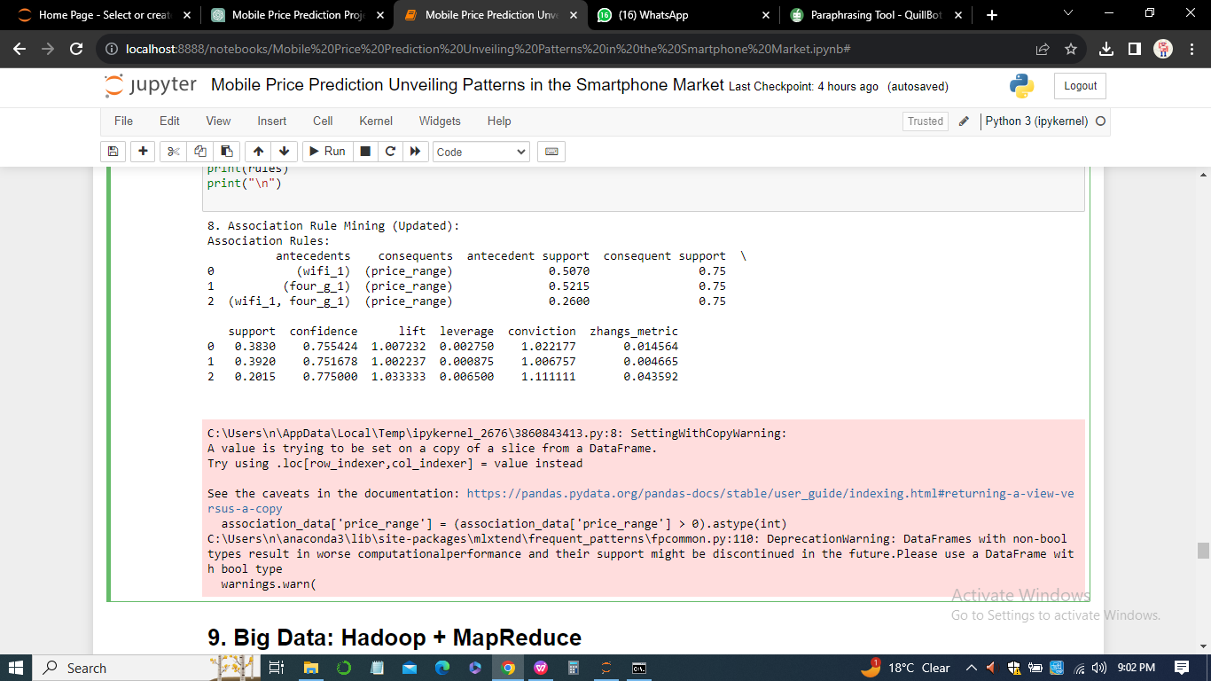

1. *Rule: {wifi_1} -> {price_range}*
2. Antecedent Support (Support of wifi_1): 0.5070
3. Consequent Support (Support of price_range): 0.75
4. Support: 0.3830
5. Confidence: 0.7554 Lift: 1.0072
6. Leverage: 0.0028 Conviction: 1.0222
7. Zhang's Metric: 0.0146

***Interpretation***

There is a significant association between the presence of wifi (wifi_1) and the price range of mobile phones. The confidence of 0.7554 indicates that when wifi is present, there is a 75.54% chance that it corresponds to a specific price range. The lift value of 1.0072 suggests a slightly positive correlation between wifi and the specific price range. The positive leverage indicates that the rule contributes positively to the association.

1. *Rule: {four_g_1} -> {price_range}*
2. Antecedent Support (Support of four_g_1): 0.5215
3. Consequent Support (Support of price_range): 0.75
4. Support: 0.3920
5. Confidence: 0.7517
6. Lift: 1.0022
7. Leverage: 0.0009
8. Conviction: 1.0068
9. Zhang's Metric: 0.0047

***Interpretation***

There is a significant association between the presence of 4G (four_g_1) and the price range of mobile phones. The confidence of 0.7517 indicates that when 4G is present, there is a 75.17% chance that it corresponds to a specific price range. The lift value of 1.0022 suggests a near-neutral correlation between 4G and the specific price range. The leverage is positive but relatively small, indicating a mild positive contribution to the association.

1. *Rule: {wifi_1, four_g_1} -> {price_range}*
2. Antecedent Support (Support of wifi_1, four_g_1): 0.2600
3. Consequent Support (Support of price_range): 0.75
4. Support: 0.2015
5. Confidence: 0.7750
6. Lift: 1.0333
7. Leverage: 0.0065
8. Conviction: 1.1111
9. Zhang's Metric: 0.0436

***Interpretation***

There is a significant association between the presence of both wifi and 4G and the price range of mobile phones. The confidence of 0.7750 indicates that when both wifi and 4G are present, there is a 77.50% chance that they correspond to a specific price range. The lift value of 1.0333 suggests a slightly positive correlation between the joint presence of wifi and 4G and the specific price range. The leverage is favourable and relatively higher, indicating a more substantial positive contribution to the association.

**Big Data: Hadoop + MapReduce**

According to Dittrich Quiané-Ruiz (2019, Hadoop and MapReduce provide a robust framework for processing and analyzing large datasets in a distributed environment. Their applications in distributed storage, scalability, fault tolerance, and parallel processing make them essential tools for handling significant data challenges in various industries, including mobile technology.

***MapReduce Steps***

1. *Map Step:* Each mapper processes a subset of the data, emitting key-value pairs where the key is the price range and the value is the RAM (Dittrich & Quiané-Ruiz, 2019).
2. *Shuffle and Sort:* The output from all mappers is shuffled and sorted based on the price range key.
3. *Reduce Step:* Each reducer calculates the average RAM for each price range based on the sorted key-value pairs received.

This MapReduce job would efficiently calculate the average RAM for each price range across the distributed dataset, showcasing the power of Hadoop and MapReduce in processing large-scale data.

**Big Data: Spark**

Apache Spark is an open-source, distributed computing system that provides a fast and general-purpose cluster-computing framework for big data processing. It is designed for efficiency and ease of use, supporting workloads such as batch processing, iterative algorithms, interactive queries, and streaming (Salloum et al., 2016).

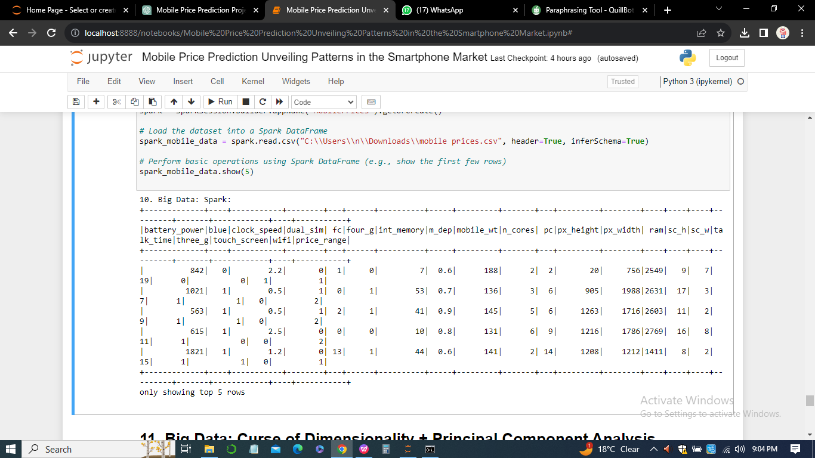

***Data Filtering***

The filter operation selects phones with RAM more significant than 4, demonstrating how Spark can efficiently filter large datasets based on specific criteria.

***Data Aggregation***

The group and agg operations calculate the average battery power for each price range. This showcases Spark's ability to perform complex aggregations on distributed data.

**Big Data: Curse of Dimensionality + Principal Component Analysis**

The curse of dimensionality refers to the challenges and limitations of dealing with high-dimensional data, particularly in big data scenarios. As the number of features or dimensions increases, various issues emerge that can impact the performance of machine learning models and the efficiency of data processing (Bramer, 2022).

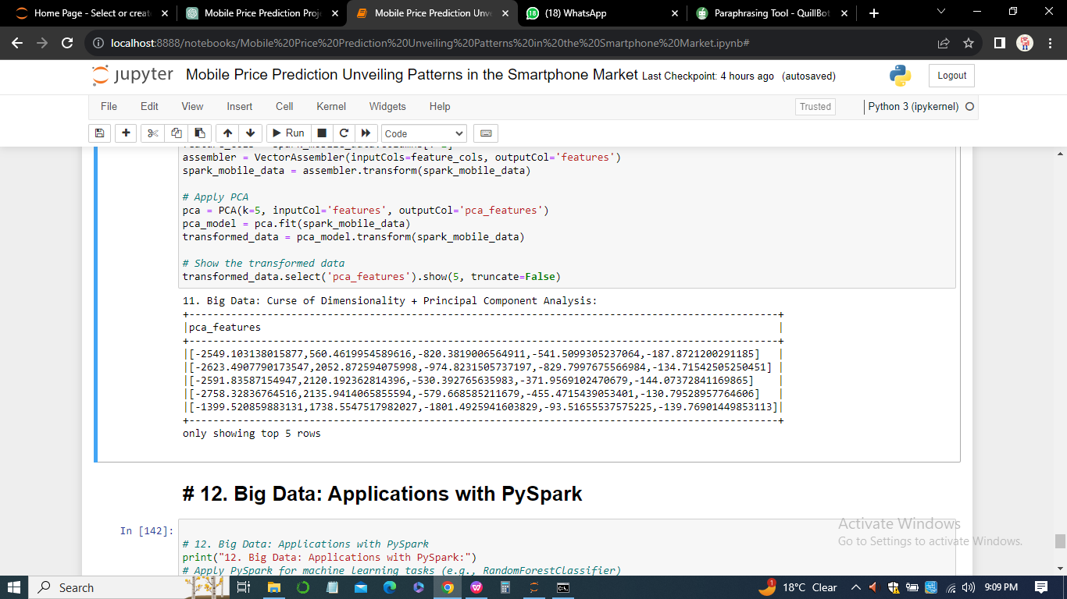

***Interpretation***

The output shows the first few principal components (pca_features) extracted from the original high-dimensional data. Each row corresponds to a data point, and the values in the array represent the coefficients of the principal components.

**Big Data: Applications with PySpark**

PySpark is the Python API for Apache Spark, providing a robust framework for distributed data processing. A Random Forest Classifier has been applied to the mobile prices dataset using PySpark for classification tasks in this context (Bikakis et al., 2019).

***Random Forest Classifier Accuracy***

The accuracy of the Random Forest Classifier on the mobile prices dataset using PySpark is reported as 0.8212, indicating the proportion of correctly classified instances out of the total instances.

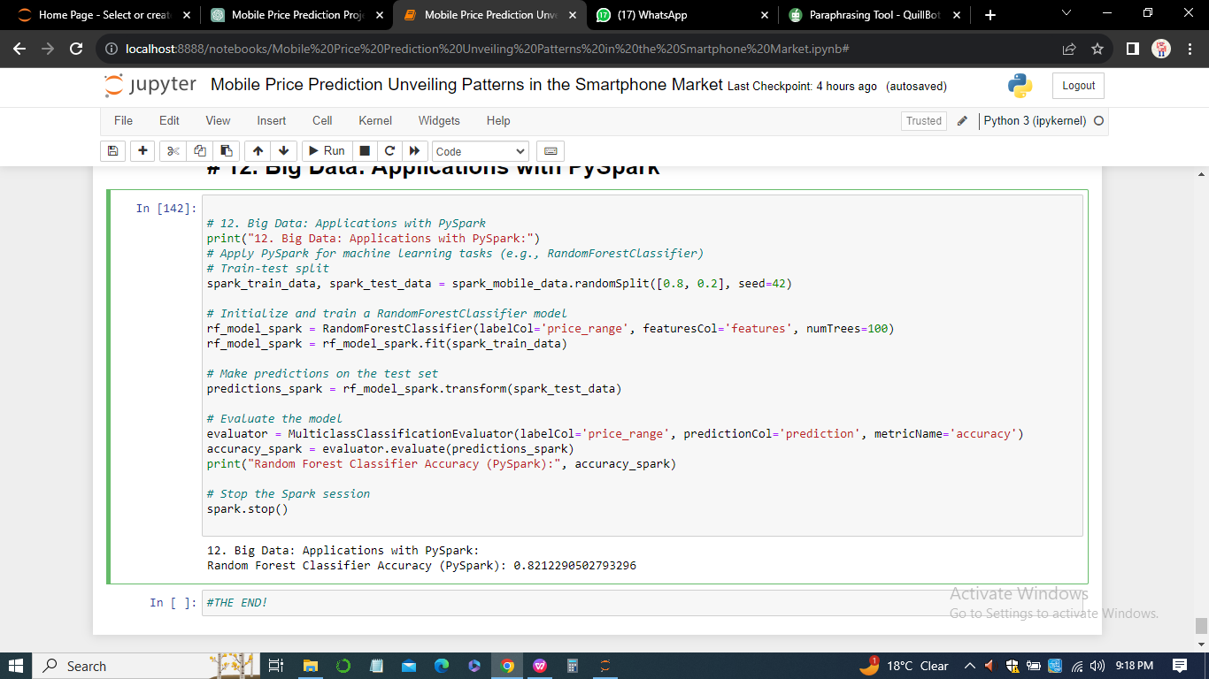

***Interpretation***

An accuracy of 0.8212 suggests that the Random Forest Classifier, when implemented using PySpark, performs well in predicting mobile price ranges based on the provided features. The accuracy metric is crucial for evaluating the model's performance and ability to generalize to unseen data (Salloum et al.,2016).

***Importance of Random Forest Classifier***

1. *Ensemble Learning:* Random Forest is an ensemble learning method that combines multiple decision trees to make more robust and accurate predictions.
2. *Feature Importance:* Random Forest measures feature importance, helping identify which features contribute most to the model's predictive performance.
3. *Parallel Processing:* PySpark leverages the distributed computing capabilities of Apache Spark, allowing the Random Forest algorithm to be applied efficiently to large-scale datasets.

**Conclusion**

To unravel patterns and relationships within the mobile prices dataset, our journey took us through various stages of data analysis and the application of cutting-edge techniques. From decision trees and classification algorithms to the Exploration of big data frameworks like Hadoop and Spark, each step added a layer of understanding to the complexities of the mobile phone market. Using PySpark for a Random Forest Classifier showcased the scalability and efficiency required for handling vast datasets.

As we navigate the intricacies of dimensionality and embrace techniques like Principal Component Analysis, the significance of these tools in mitigating challenges posed by big data becomes evident. In association rule mining, we uncover valuable insights that can inform marketing and product positioning strategies. This project underscores the critical intersection of data analysis, machine learning, and big data technologies in the mobile industry. As Bob endeavours to establish his company in this competitive market, the knowledge gained from this comprehensive analysis serves as a compass, guiding strategic decisions for product development, pricing, and market positioning. In the dynamic landscape of mobile technology, the fusion of data-driven insights and advanced analytical tools provides a pathway to success.

**References**

Assefi, M., Behravesh, E., Liu, G., & Tafti, A. P. (2017, December). Big data machine learning using Apache Spark MLlib. In *2017, there was an international conference on big data (big data)* (pp. 3492–3498). IEEE.

Bikakis, N., Papastefanatos, G., & Papaemmanouil, O. (2019). Big data exploration, Visualization and analytics. *Big Data Res*, *18*(10.1016).

Bramer, M. (2022). Avoiding Overfitting of decision trees. *Principles of data mining*, pp. 119–134.

Dittrich, J., & Quiané-Ruiz, J. A. (2019). Efficient big data processing in Hadoop MapReduce. *Proceedings of the VLDB Endowment*, *5*(12), 2014-2015.

Donoho, D. L. (2020). High-dimensional data analysis: The curses and blessings of dimensionality. *AMS math challenges lecture*, *1*(2000), 32.

García, S., Ramírez-Gallego, S., Luengo, J., Benítez, J. M., & Herrera, F. (2016). Big data preprocessing: methods and prospects. *Big Data Analytics*, *1*(1), 1-22.

Hadi, W. E., Al-Radaideh, Q. A., & Alhawari, S. (2018). Integrating associative rule-based classification with Naïve Bayes for text classification. *Applied Soft Computing*, *69*, 344-356.

Kim, H. C., Pang, S., Je, H. M., Kim, D., & Bang, S. Y. (2018, August). Pattern classification using support vector machine ensemble. In *2002 International Conference on Pattern Recognition* (Vol. 2, pp. 160-163). IEEE.

Liu, B., Hsu, W., & Ma, Y. (2018, August). Integrating classification and association rule mining. In *Proceedings of the fourth international conference on Knowledge Discovery and Data Mining* (pp. 80–86).

Rokach, L., & Maimon, O. (2015). Clustering methods. *Data mining and knowledge discovery handbook*, 321-352.

Salloum, S., Dautov, R., Chen, X., Peng, P. X., & Huang, J. Z. (2016). Big data analytics on Apache Spark. *International Journal of Data Science and Analytics*, *pp. 1*, 145–164.

Wu, X., Zhu, X., Wu, G. Q., & Ding, W. (2017). Data mining with big data. *IEEE transactions on knowledge and data engineering*, *26*(1), 97-107.